Dimensional analysis Practice Key
- My dog ran 3.22 km this morning. How many mm did my dog run?

$$?mm=3.22 km×\frac{1000 m}{1 km}×\frac{1000 mm}{1 m}=3.22×{10}^{6} mm$$

- An alloy is composed of silver and copper. If the alloy is 48.2% silver, how many grams of the alloy are required to provide 75.0 grams of silver?

$$?g alloy=75.0 g Aq×\frac{100 g alloy}{48.2 g Ag}=156 g alloy$$

- The distance between San Diego and Dallas is 1906 km. What is this distance in feet?

$$?ft=1906 km×\frac{1000 m}{1 km}×\frac{100 cm}{1 m}×\frac{1 in}{2.54 cm}×\frac{1 ft}{12 in}= 6.253×{10}^{6} ft$$
$$(or 6253000 ft)$$
- The density of bronze is 7.64 g/mL. If a bronze statue has a mass of 15.32 lb, what is the volume of the statue in L?

$$?L=15.32 lb ×\frac{454 g}{1 lb}×\frac{1 mL}{7.64 g}×\frac{1 L}{1000 mL}= 0.910 L$$

- The temperature outside is 27ºC. What is this temperature in ºF? In K?

$$℉=\left(27℃×\frac{180℉}{100℃}\right)+32℉=49℉+32℉=81℉$$

$$K=27℃+273=300 K$$

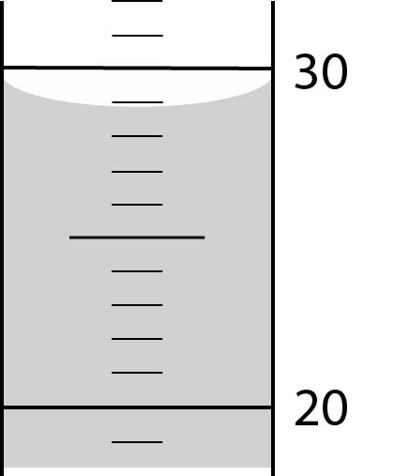
- What is the volume of liquid in the graduated cylinder at the right? (The cylinder is calibrated in mL)

  - mL

- If 48.5 mL of methanol are produced in a fermentation vat every day, what is the rate of production in gallons of methanol per year? (1 gal = 4 qt)

$$? \frac{gal}{year}=\frac{48.5 mL}{day}×\frac{1 qt}{946 mL}×\frac{1 gal}{4 qt}×\frac{365 day}{1 yr}=\frac{4.67 gal}{yr}$$

